Chapter 7: BTS Site Visit

I visited a number of indoor and outdoor BTSs. In indoor BTS all parts of it is separated into a room. But in outdoor BTS all parts are along with into a box except the antenna.
Major parts of BTS:
    - Rectifier
    - Battery
    - Units
    - E1 channels
    - Sensors
    - Node(2G & 3G)
    - RRU(Remote Radio Unit)(different for 2G & 3G )(6 RRU in 1 BTS)
    - Antennas(3 for 2G & 3 for 3G)
    - Microwave antenna.
Etc...

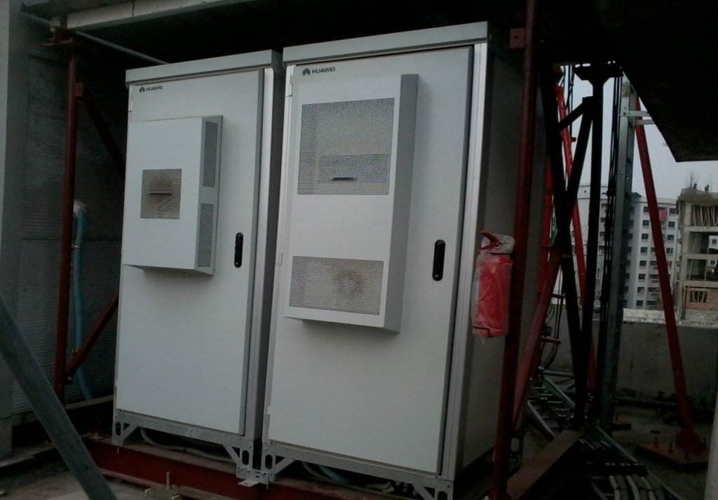
Fig 7.1: Basic Structure of an Outdoor BTS.

  - Visit to Outdoor BTS
An Outdoor BTS is like a double door fridge, a box where all the equipments are nicely settled. Built-in air-condition inside. In right side part there are battery racks and in left side part there are other equipments or vice versa. [Fig 7.1 & 7.2]
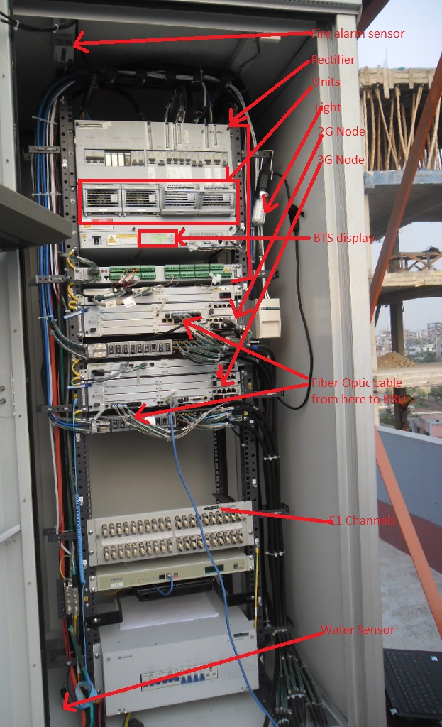
Fig 7.2: Different parts of an outdoor BTS are shown.
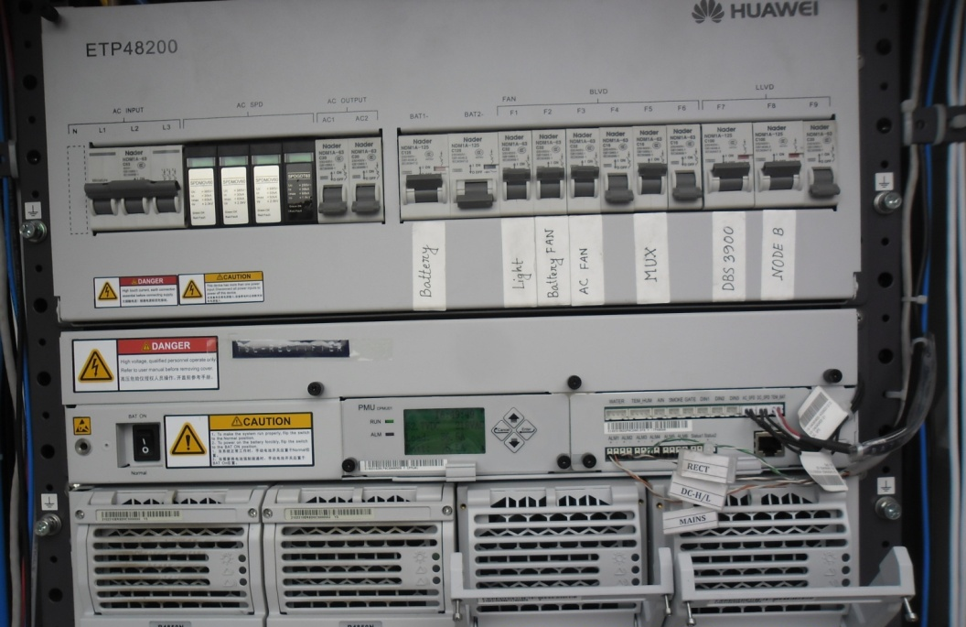
Fig 7.3: Rectifier and Module units.
Rectifier: It converts AC (Alternating Current) power into DC (Direct Current) power and maintains the power of the BTS from the AC and DC source. In indoor BTS it is separated from the Nodes and other parts of it, but in outdoor BTS it is attached with everything into a metal box.
Module Units: There are 4-7 units in a BTS usually. It depends on the traffic how much units will be used among these.
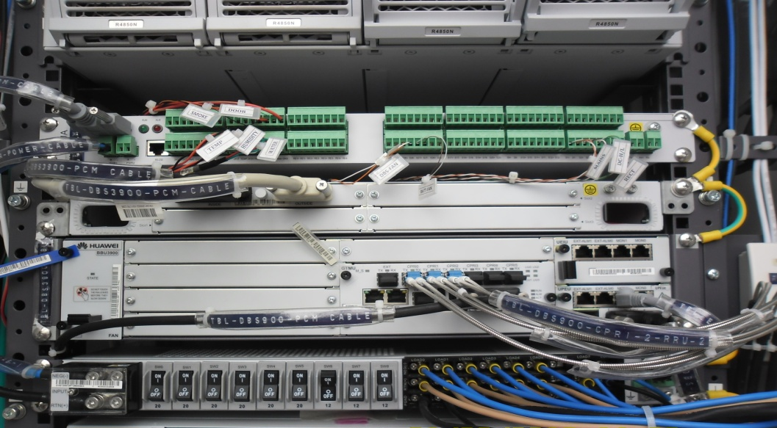
Fig 7.4: Node of 2G connection and Alarms.

Sensors: There are different types of sensors in a BTS, these are
- Smoke Sensor
- Water Sensor
- Temperature Sensor
Node (2G & 3G): It is the hardware that is connected to the mobile phone network that communicates directly with mobile handsets. In contrast with GSM base stations, Node B uses WCDMA/TD-SCDMA as the air interface technology. As in all cellular systems, such as UMTS and GSM, the Node B contains radio frequency transmitter(s) and the receiver(s) used to communicate directly with mobile devices, which move freely around it. In this type of cellular network, the mobile devices cannot communicate directly with each other but have to communicate with the Node B.
Traditionally, the Node Bs have minimum functionality, and are controlled by an RNC (Radio Network Controller). However, this is changing with the emergence of High Speed Downlink Packet Access (HSDPA), where some logic (e.g. retransmission) is handled on the Node B for lower response times.
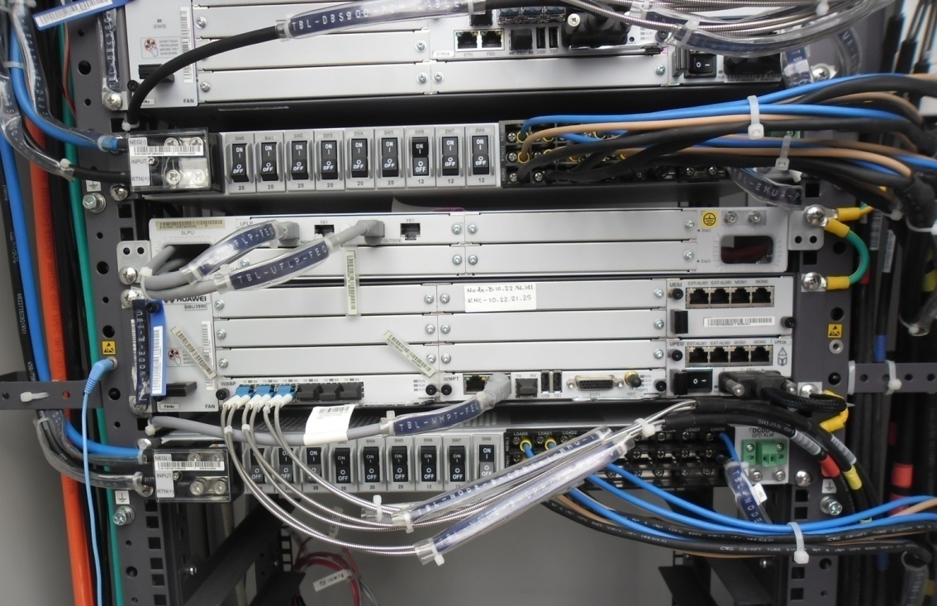
Fig 7.5: Node B of a 3G network,
the fiber optic connections to the Node B through optical fibers.
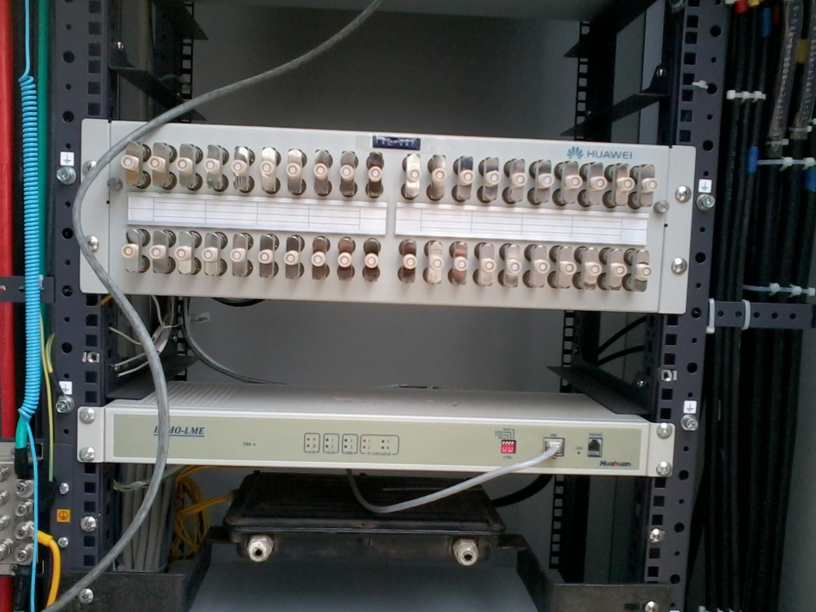
Fig 7.6: DDF of a BTS

DDF: DDF is the Digital Distribution Frame of the BTS. A distribution frame is a passive device which terminates cables, allowing arbitrary interconnections to be made.

Battery Bank: There are 24 batteries in a BTS and each of these having 2V-2.2V and a total of about 54V. The lowest BTS voltage is set -45V. If the batteries supply less then -45V then the BTS will be out of transmission and if it reaches to -48V then it sends alarm to the OMC NOC of power failure. [Fig 7.7]
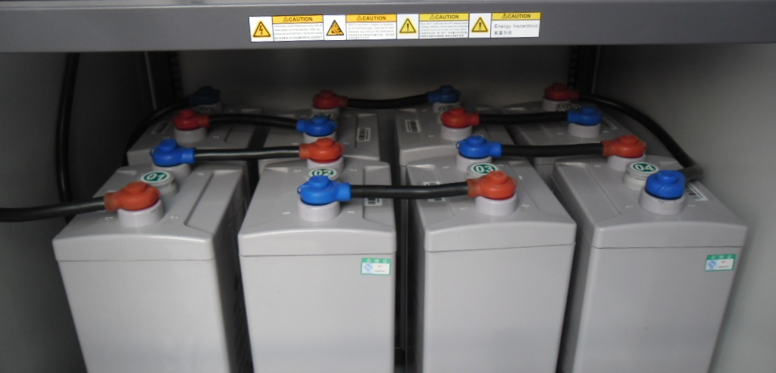
Fig 7.7: Battery Bank (Outdoor BTS).
There are 24 units of battery in a battery bank. In each tray there are 8 units of battery. 3 trays in a battery bank total of 24 units.

  - Visit to Indoor BTS
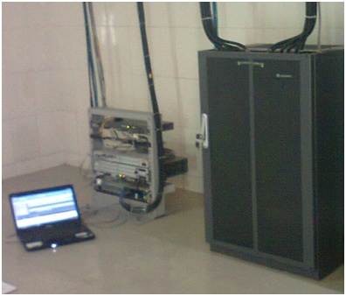
Fig 7.8: Picture of an indoor BTS.
In the picture [Fig 6.8], the left part is the NODE part (3G) and the right part is BTS (2G).
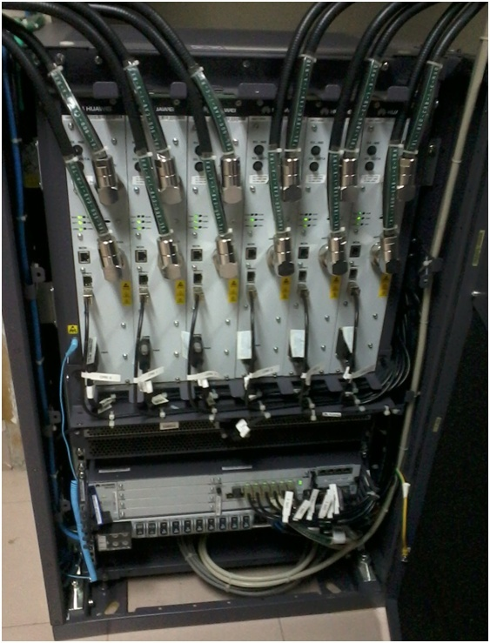
Fig 7.9: Internal Structures of a Huawei Indoor BTS (2G).
Power System: Power System is one of the main sectors in a telecom organization. Input power of Telecom equipment may be: DC 24/ -48/ 60 V. In TBL, they use -48 V in most of the cases.
The purposes are:
- To ensure constant DC power for the equipment,
- To ensure distortion less, surge protected, safe AC input power.
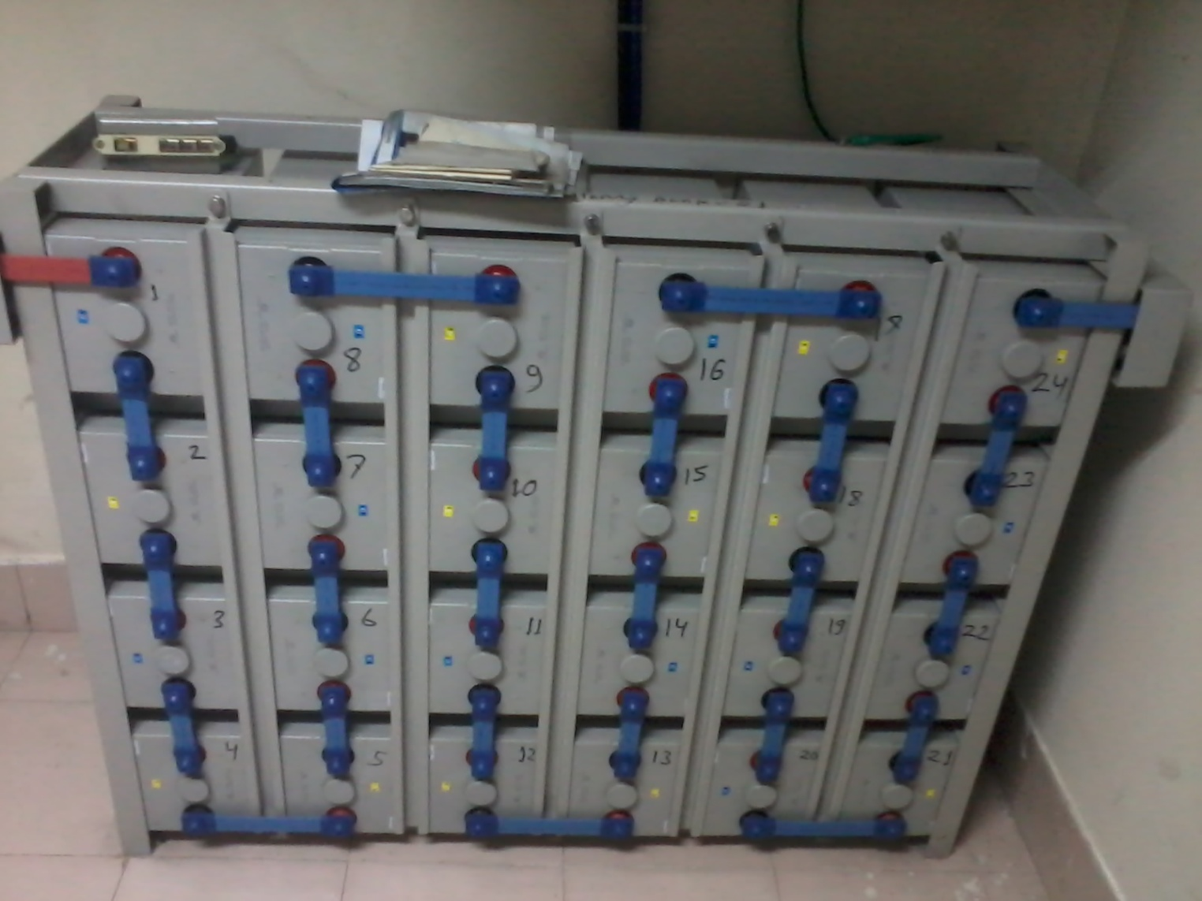
Fig 7.10: Battery Bank in the Indoor BTS.
There are also 24 units of batteries in a indoor battery bank.
Why DC instead of AC Power Supply:
- A filter for all the noise (EMC, surges etc) present on the AC power lines.
- All telecom equipment (PABX, Base Stations, Main Switches) have to operate when the AC supply (mains) is absent.
- The telecom equipment has to be supplied by stored energy while the AC supply (mains) is absent.
- Batteries are today the cheapest and most efficient way to store electrical energy, and can only be charged by DC.

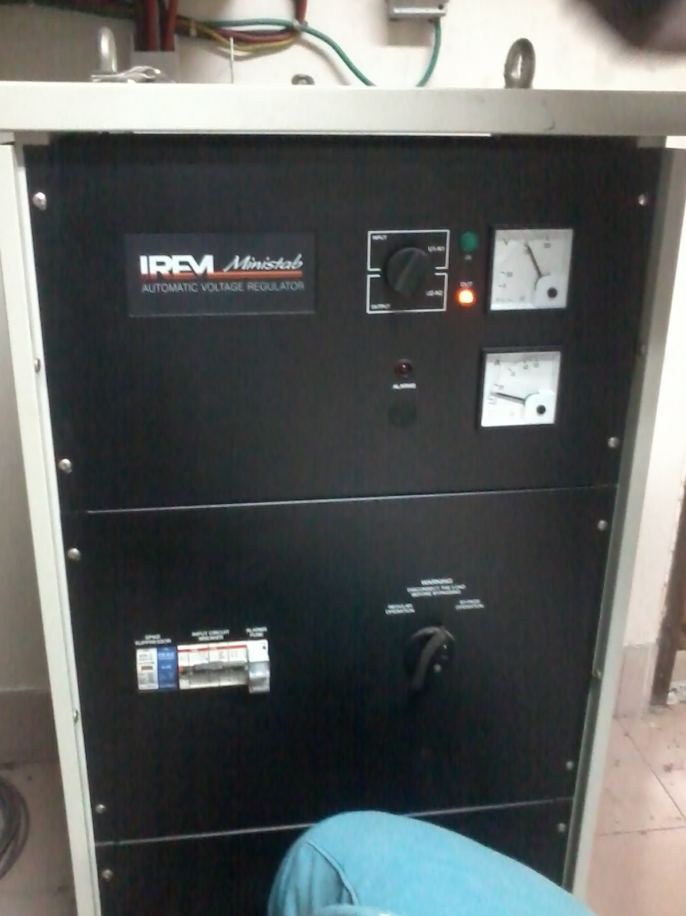
Fig 7.11: Automatic Voltage Regulator.
AVR: AVR is Automatic Voltage Regulator. A voltage regulator is designed to automatically maintain a constant voltage level. It may use an electromechanical mechanism, or electronic components. Depending on the design, it may be used to regulate one or more AC or DC voltages.
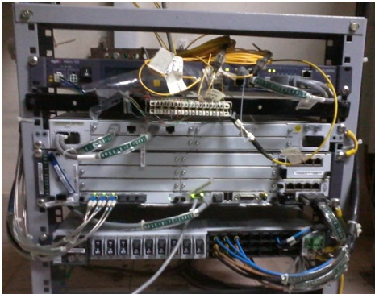
Fig 7.12: NODE B of a Indoor BTS.

Node B: A BTS in 3G is called Node B. It is a term to denote a base station in UMTS terminology. Traditionally, the Node B’s have minimum functionality, and are controlled by an RNC (Radio Network Controller). However, this is changing with the emergence of High Speed Downlink Packet Access (HSDPA), where some logic is handled on the Node B for lower response times.
  - BTS Antennas
Antennas: In all BTS directional antennas are used. One is microwave antenna which is used for microwave transmission between BTS to BTS or BTS to BSC/MSC or vice versa. Three sector antennas are used for BTS to MS communication which works on a desired frequency for example 900MHz or 1800MHz. These 3 antennas are set 120 angels to each other which is mesured by compus , mesured from 0 (north) called azimuth angle. These antennas are also tillted a perticular angle which is mesured by the tillting mitter. It depandes on the coverage area the antenna is going to cover as it’s networking area. As frequency increases the antenna size decreases.

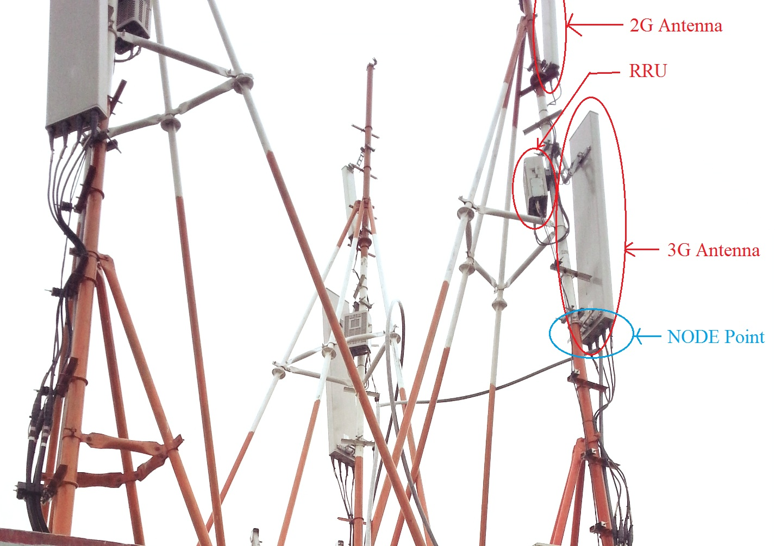
Fig 7.13: 3 Way faced Antennas.
In every way there is a GSM 900, GSM 1800 and WCDMA 2100 (3G) frequency directed.
RRU: A remote radio unit (RRU) in a radio base station system can include a cyclic prefix (CP) module with a CP adder for downlink channel processing and a CP remover for uplink channel processing. The RRU can be configured to communicate with a base band unit (BBU) via a physical communication link and can communicate with a wireless mobile device via an air interface. [Fig 6.12]
Remote Radio Units are generally installed in towers and are controlled by a controller placed inside a closed shelter on the ground nearby the tower. The connection between the RRU and the controller is generally optical. The RRU and the controller form the BTS or Base Transceiver Station which is widely used in cellular communication.
RRU are different for 2G & 3G but same RRU works on different frequency (900MHz & 1800MHz).

