Chapter 6: Operation with CME

  - CME
CME (Configuration management Express) is a centralize operation maintains software. It’s a user friendly graphical user interface, where MML commands create on backend and after execution it goes to RNC and makes the changes. We can remotely add/delete TRX in BTS (3900 series of Huawei BTS) using online CME.

Things to do before Add/remove TRX:
Step 1: Log into online CME
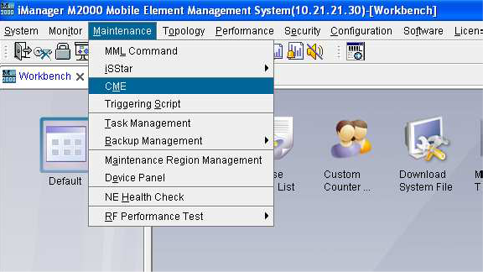

Step 2: Create your own project specifying the work area (for example: RMNBSCH08)
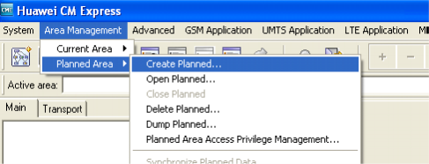
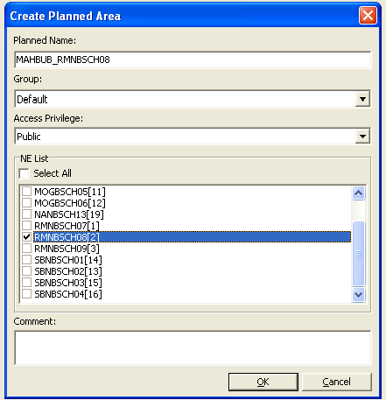

Step 3: Synchronize the planned area data
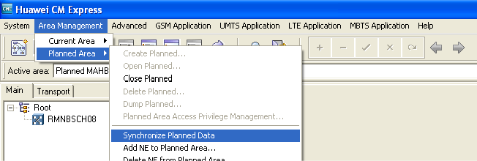
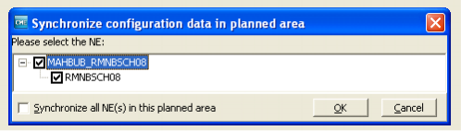
  - TRX Addition process using Online CME

Step 1: Open BTS topology.
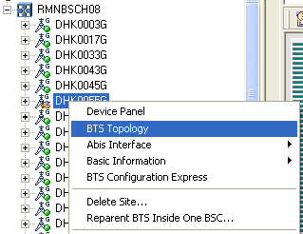

Step 2: Right Click Cell GUI. Then select the assigned frequency.
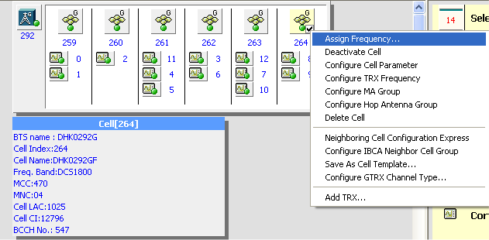
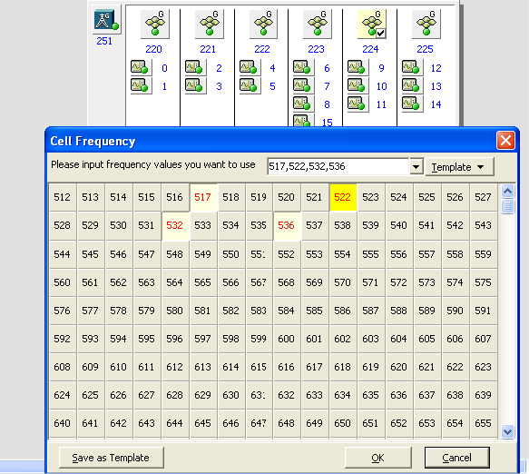

Step 3: Add TRX
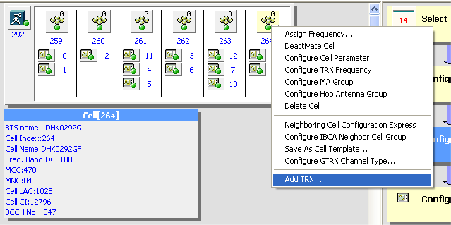

Step 4: Bind TRX with the TRX board (GRFU/RRU)
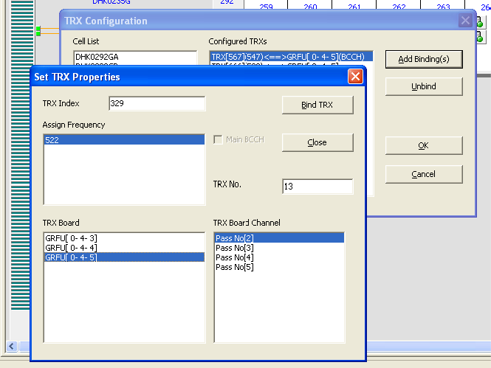
Select proper GRFU/RRU.

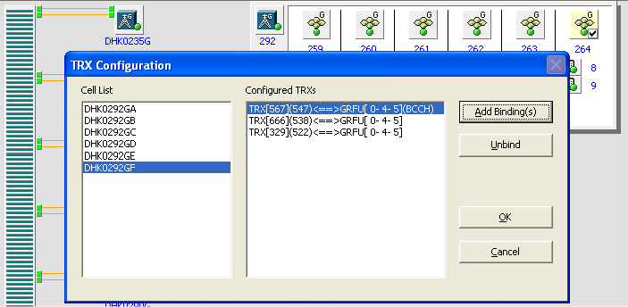
Press OK

Step 5: Adjust following data from TRX Configuration Express
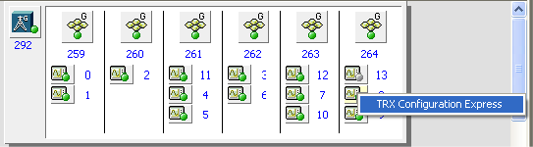

TRX per  GRFU/RRU | One | Two | Three | Four | Five | Six
Power Type | 20W or 40W | 20W/27W/40W | 27W | 20W | 16W | 13W
Sum of TRX power can’t exceed 80W in any GRFU/RRU
TCH rate adjust Value: Yes
Power fine tune: 0.0dB

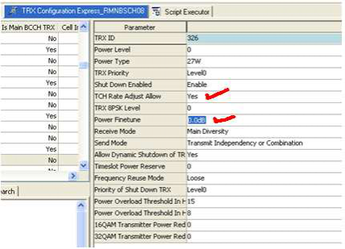

Step 6: Activate TRX.
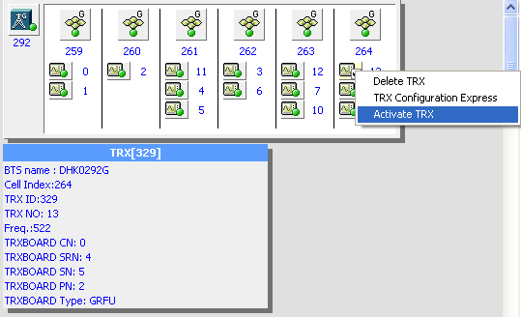

Step 7: Reset Frequency Hopping data.
- Cancel Frequency hopping data
- Reset frequency hopping data.

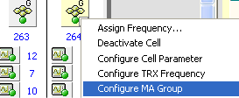

 | HSN Value
Cell A/ Cell D | 19
Cell B/ Cell E | 28
Cell C/ Cell F | 3

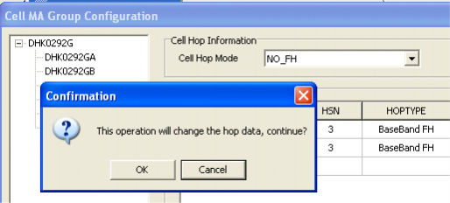

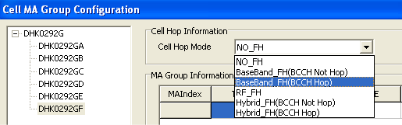

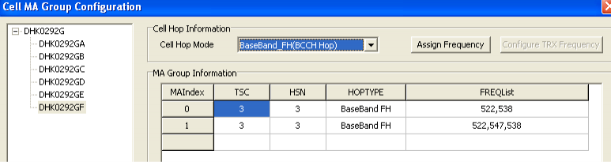

Step 8: Save the modification.
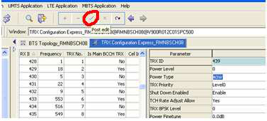

Step 9: Export incremental script.
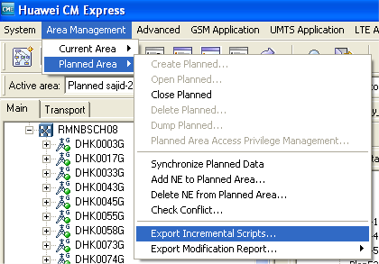 | 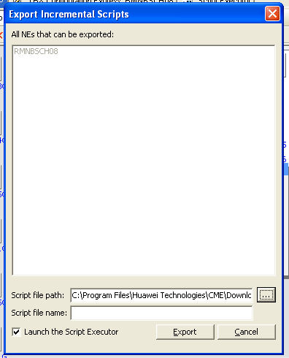
Step 10: Final Execution:
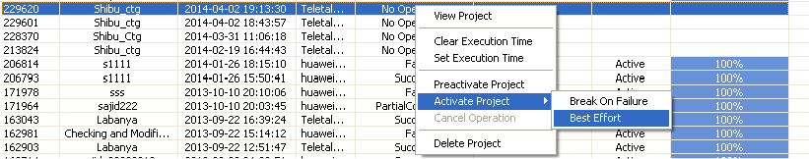

  - TRX Deletion process using Online CME

Step 1: Delete Hopping data
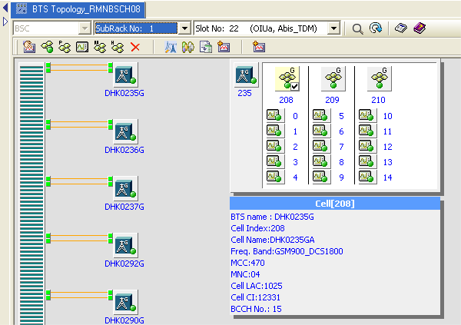
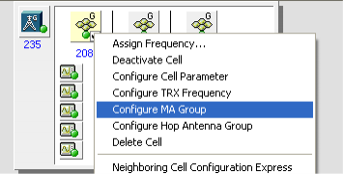
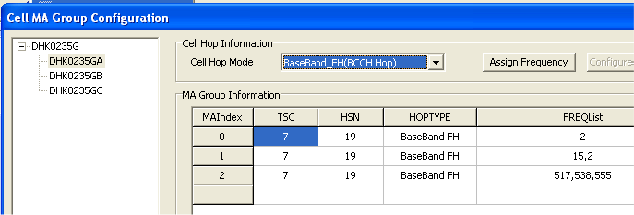

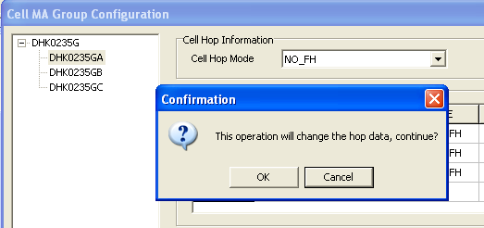

Step 2: Deactivate cell.

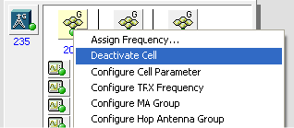

Step 3: Delete TRX.
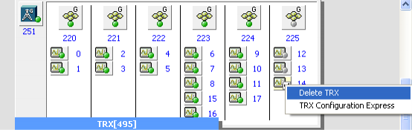

Step 4: Adjust TRX power using TRX configuration express.
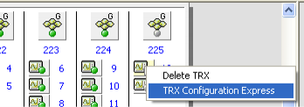

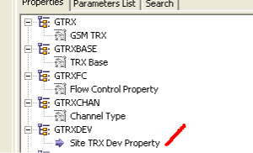
Step 5: Adjust the Walt.
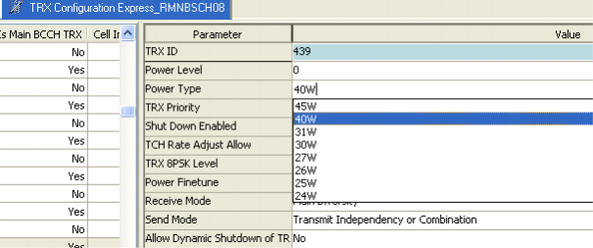

Step 6: Activate cell.
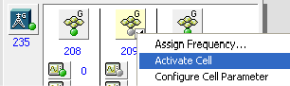

Step 6: Reset Hopping data if number of TRX is more than one.
Step 7: Save the modification.
Step 8: Export incremental script.
Step 9: Final Execution.

(Step 6 to 9 is same like before.)

Precaution:
- If we find “Carrier Configuration error” alarm ID: 28010, then we have to readjust TRX power.
- After executing incremental script always check whether all new TRXs are at least idle.
- TRX may be faulty due to E1 fault or fault in GRFU or RRU card.

  - Monitoring & Identification of Transmission Problems
As it stated before Teletalk doesn’t handle the transmission problems that much. Most are conducted by the 3rd party companies (BPL, Summit Telecom, Fiber@home). But links between BSC-BSC and BSC-MSC are conducted by Teletalk Bangladesh LTD.
First of all the first step is to open the Software “Teletak VNC Viewer and Optix Manager T2000” and check if there is a problem or not:
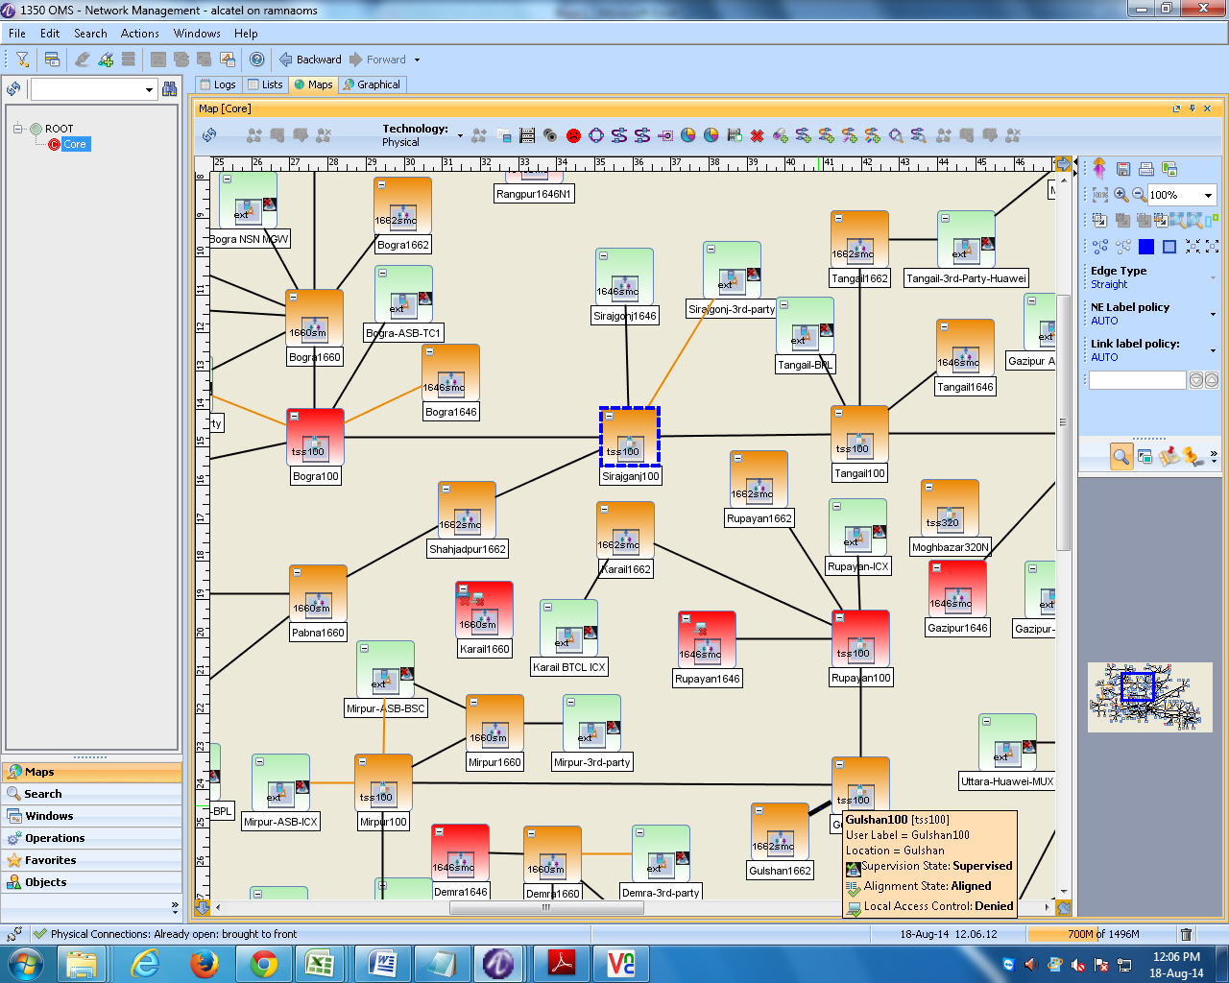
Fig 6.1: Teletak VNC Viewer and Optix Manager T2000 by Alcatel.
The Red ones are down .The Orange ones mean there is a major problem but still not down yet. Usually then a team of experts go to the place and with the help of the contractor dig up or the process needed to fix the links and do it .The green ones are working fine.
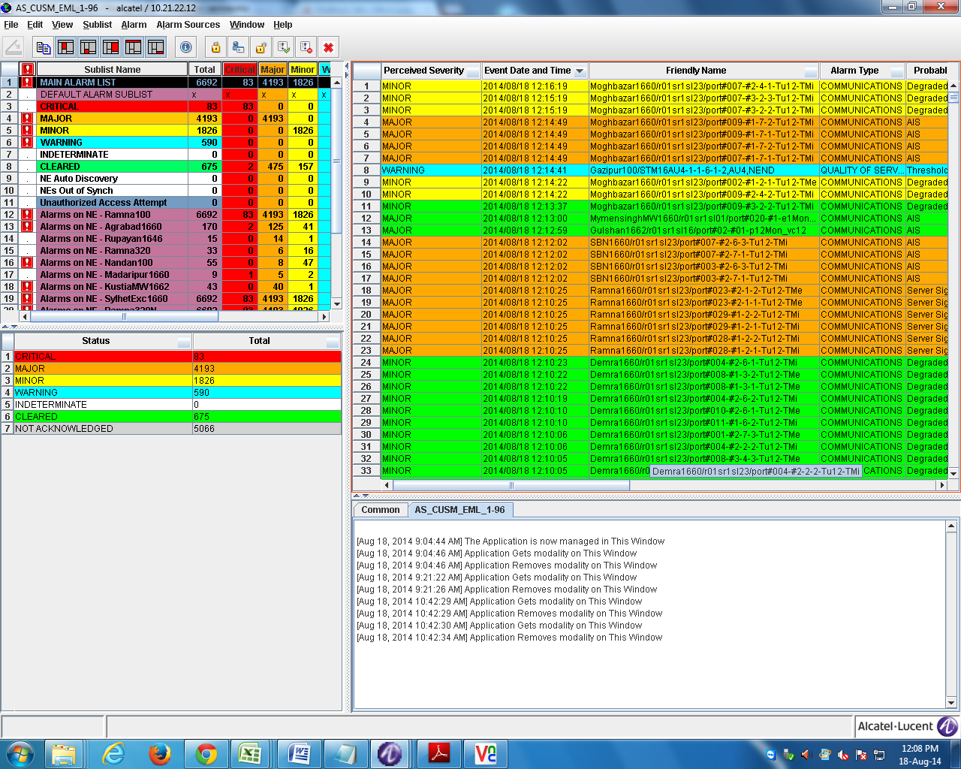
Fig 6.2: List of Faults of different BTSs in Optix Manager T2000.

