Chapter 4: A remarkable change in TBL (Use of CBS for billing system)

In addition to GPRS network Teletalk Bangladesh LTD has been using IN (Intelligent Network) for pre-paid billing and the Billing for Post-paid billing, which is slower and insufficient to provide services on time to customers. CBS (Convergent Billing system) is much faster and capable to provide services on time having huge capacity.

4.1. Intelligent Network (IN)
Intelligent Network (IN) is a telephone network architecture originated by Bell Communications Research (Bellcore) in which the service logic for a call is located separately from the switching facilities, allowing services to be added or changed without having to redesign switching equipment. According to Bell Atlantic, IN is a "service-specific" architecture. That is, a certain portion of a dialed phone number, such as 800 or 900, triggers a request for a specific service. A later version of IN called Advanced Intelligent Network (AIN) introduces the idea of a "service-independent" architecture in which a given part of a telephone number can interpreted differently by different services depending on factors such as time of day, caller identity, and type of call. AIN makes it easy to add new services without having to install new phone equipment. [Fig 3.1]

Bellcore called its network IN/1. It included this model:
- The customer's telephone
- The switching system (starting with the switch a call is handled by first, usually at a telephone company central office (CO)
- A database called a service control point (SCP) that defines the possible services and their logic
- A service management system (SMS)
The visual depicts the elements of a generic intelligent network (IN) architecture. The network elements are either physical or functional, and include those listed below -
- Service switching points (SSP): As defined for SS7.
- Service control points (SCP): As defined for SS7.
- Signaling transfer points (STP): As defined for SS7.
- Service management system (SMS): Provides the functions necessary to provision, maintain, and administer AIN services.
- Network access points (NAP): Provide IN functions to a switching office or other equipment (e.g., PBX) that does not have SSP functions. A NAP uses existing signaling facilities to access an SSP for AIN services via the SS7 network.
- Adjunct: Performs similar functions as an SCP, but connected directly to an SSP. Provides local service control functions.
- Intelligent peripheral (IP): Provides access to peripheral equipment (call recorders, announcement units, etc.) for IN functions.
The combination of these elements allows the creation and management of advanced call services, independent of the serving central offices.

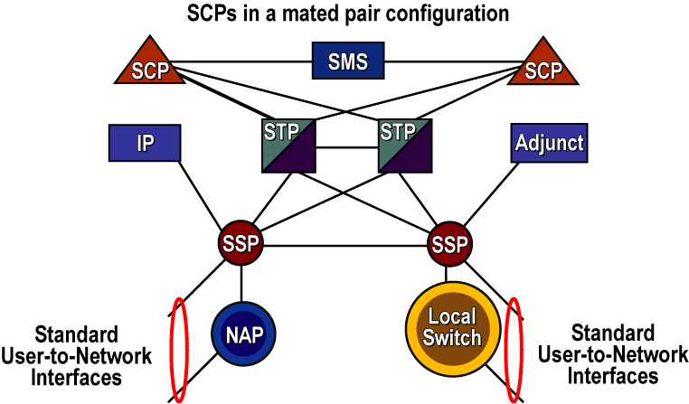
Fig 4.1: Architecture of IN
(http://www.hill2dot0.com/wiki/index.php?title=Intelligent_network)
Exiting Capacity
Teletalk has 4 SCP (Service Control Point) to serve their customers:
- SCP1 at Ramna: Capacity- 6 lakhs
- SCP2 at Ramna: Capacity – 17 lakhs
- SCP3 at S: Capacity- 12 lakhs
- Scp4 at SBN: Capacity – 12 lakhs

Capable of providing various new IN services rapidly:
- Easy to create new services by customers themselves
- Easy to upgrade or modify IN services according to different requirements
- Easy to control the life cycle of IN services

MIN System Components:
- SCE --- Service Creation Environment
- SMP --- Service Management Point
- SCP --- Service Control Point
- SSP --- Service Switching Point
- SMAP --- Service Management Access Point
- CMP --- Card Management Point
- IP --- IN Peripherals
- VC --- Voucher Center

Service Management Point -- SMP
SMP is a computer system based on UNIX platform, which is for:
- Service Management
- Network Management
- Charging Management
- Subscriber Management
- Storing Billing Records
- Managing Scp Remotely
- Smap Access Management

Service Management Access Point – SMAP
SMAP is a PC based on Windows 9x/2000 system, which -
- is the client of SMP. SMAP accesses the data from SMP database.
- is the man machine interface of SMP. Most management functions of SMP must be configured and executed on SMAP.
- has a graphic interface and easy to use.

Voucher Center -- VC
VC is a computer system based on UNIX platform, which is for:
- storing scratch cards
- voucher cards management
- recharging subscribers

Card Management Point -- CMP
CMP is a PC based on Windows 9x/2000 system, which -
- is the client of VC. CMP accesses the data from VC database.
- is for voucher cards management
- is the man machine interface of VC. Most management functions of VC must be configured and executed on CMP.
- has graphic interface and easy to use.

Service Control Point -- SCP
SCP is a computer system based on UNIX platform, which -
- communicates with SSPs and IPs via CAP
- storing billing records temporarily
- controls IN calls
- controls IN charging
- executes service logics Controls call traffic.

Service Switching Point -- SSP
SSP is a special switching system, which
- can trigger IN calls, and then
- report IN calls to SCP, and after receiving the instructions from SCP, SSP will
- make the connection between the caller and the called.
- communicates with SCP via INAP or CAP
- generates billing records after successful IN calls
- Communicates with local switches via CCS7.
Sometimes, SSP also has the functions of IP. In overlay MIN, there are stand alone SSP/IPs, while in target MIN, SSP is just part of the function of MSC or GMSC.

Intelligent Peripheral -- IP
IP is the system for
- Playing voice prompts to IN service users
- Collecting number input from IN service caller IP communicates with SSP via ISUP and with SCP via INAP. IP usually has very large storing capacity to record voices. Sometimes, IP is combined with SSP.

4.2. Convergent Billing System

Convergent Billing
Deliver innovative products and services quickly and cost-effectively using a convergent billing solution that is engineered to meet the specific needs of today’s communications service providers.
Real time, convergent billing solutions allow service providers to use a single system for multiple access technologies and billing methods. Prepaid, post-paid, wireless, cable, broadband, satellite, data, voice, or SMS - the right convergent solution can drive subscriber acquisition, increase revenues and improve profitability.
Redknee’s convergent billing solutions provide real-time transaction capabilities and customer usage data to all groups within the service provider organization, enabling billing, marketing, pricing, customer care, IT and network departments to monetize the value of each subscriber transaction while personalizing and enhancing the subscriber experience.
The Convergent Billing Solution (CBS) is an end-to-end convergent charging and billing solution for all types of networks, services and subscribers. As a unified system aimed to reduce TCO, this solution allows telecom operators to have a faster time to market and increase their revenue. It is a flexible charging and billing engine that help operators expand market share through personalized marketing activities, improve operational efficiency through express billing, and reduce costs. More importantly, it helps deliver a high level of QoE through real-time service and hence ensure customer loyalty.
A convergent billing solution from Redknee equips service providers with a solution that is:
- Agile – architected to meet growing and changing needs of wireless, multi-play and cloud providers while delivering sophisticated features and supporting complex business models
- End-to-end – a turnkey solution that addresses activation, provisioning, customer care, unified rating, messaging, real-time charging, billing and invoicing.
- Out of the box – organically designed and based on technology with more than 100 patents filed, Redknee’s truly convergent solutions mean low configuration is required so you can launch to the market faster
- Flexible – enables the quick implementation of new real-time pricing structures for both prepaid and postpaid subscribers, and the ability to launch targeted, cross service bundles and promotions quickly
- Valuable – supports new services, applications and business models while reducing fraud via real-time access to subscriber data
- Partner Support – Open APIs support third party partnerships with built-in revenue share capabilities, including MVNO/MVNE arrangements

Features:
Full service convergence
- The CBS is a convergent system for all types of networks and services, which will greatly help reduce CAPEX;
- It is a unified system that can greatly improve O&M efficiency and bring down OPEX.
Full customer support
- The CBS is a system aimed for all customer types (individual, home and business) and all charging types (prepaid, postpaid and hybrid);
- It provides unified customer view and management that can accelerate personalized marketing.
E2E revenue assurance
- The CBS provides real-time charging, notification, promotion and credit control to improve QoE, and reduce the bad debt risk;
- It provides express billing to improve operational efficiency, and accelerate revenue-to-cash;
- Its zero-risk embedded revenue assurance mechanism helps prevent revenue leakage.

Applications & Benefits
Since its first release in the beginning of 2007, Huawei’s CBS solution has been successfully deployed by more than 70 operators such as China Mobile, MTN, and Etisalat, serving more than 400 million subscribers. It has brought about the following benefits.

Decreasing TCO
- One system can support all types of networks, charging modes, and services so that operators do not need to build and maintain multiple systems.
- An open and standard architecture minimizes system changes caused by a new market requirement.

Increasing revenue
- Cross-network and cross-service packages and discount shorten time to market for a new service, increasing service usage and therefore ARPU.
- Based on customer segmentation, operators can provide personalized products and use promotion means to address the requirements of different customer groups, thus attracting more new customers.
- The real-time charging function gives operators an advantageous position in multiple business models by allowing them tight payment control.

Improving customer loyalty
- Abundant features (such as multi-channel self-service, online voice prompt, and short message prompt) are provided to improve QoE.
- With the credit control function, a customer can control the account expense, thus improving customer satisfaction.

Shortening time to market for a new product
- Charging products can be configured fast and launched in the target market.
After these all in CBS there are two profiles for all subscribers into the same database, one is for pre-paid and the other one is for post paid accounts. Due to having two profiles into the same database the user easily and instantly switch into other profile if needed. For sure it can be said that it is a unique opportunity to its subscribers. After launching the CBS the Teletalk Bangladesh Ltd. is earning almost 9 times batter revenue than before.

