Chapter 3: Cell and Chanel Concept

3.1. Cell
A cellular network or mobile network is a wireless network distributed over land areas called cells, each served by at least one fixed-location transceiver, known as a cell site or base station. In a cellular network, each cell uses a different set of frequencies from neighboring cells, to avoid interference and provide guaranteed bandwidth within each cell.
When joined together these cells provide radio coverage over a wide geographic area. This enables a large number of portable transceivers (e.g., mobile phones, pagers, etc.) to communicate with each other and with fixed transceivers and telephones anywhere in the network, via base stations, even if some of the transceivers are moving through more than one cell during transmission.
Cellular networks offer a number of desirable features:
- More capacity than a single large transmitter, since the same frequency can be used for multiple links as long as they are in different cells
- Mobile devices use less power than with a single transmitter or satellite since the cell towers are closer
- Larger coverage area than a single terrestrial transmitter, since additional cell towers can be added indefinitely and are not limited by the horizon
Major telecommunications providers have deployed voice and data cellular networks over most of the inhabited land area of the Earth. This allows mobile phones and mobile computing devices to be connected to the public switched telephone network and public Internet. Private cellular networks can be used for research or for large organizations and fleets, such as dispatch for local public safety agencies or a taxicab company.

Wireless Systems
- A single tower at the center called a base station.
- Powerful transmitter attached to top of base station.
- Coverage area increased by making tower taller and/or increasing transmission power.

3.2. GSM Cellular Network
Base stations (BS):
- Implement space division multiplex
- Each BS covers a certain transmission area (cell)
- Each BS is allocated a portion of the total number of channels available
- Cluster: group of nearby BSs that together use all available channels

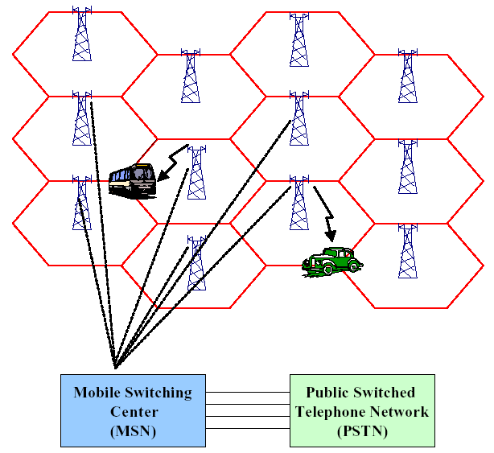
Fig 3.1: GSM Cellular Network.
Mobile stations (MS):
- Communicate only via the base station, using FDMA, TDMA, CDMA.
- Use of several carrier frequencies
- Not the same frequency in adjoining cells
- Cell sizes vary from some 100 m up to 35 km depending on user density, geography, transceiver power etc.
- Hexagonal shape of cells is idealized (cells overlap, shapes depend on geography)
- If a mobile user changes cells, handover of the connection to the neighbor cell

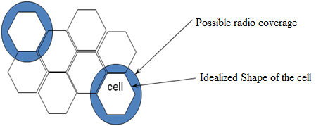
Fig 3.2: Segmentation of the area into cells

Cell size:
- 100 m in cities to 35 km on the country side (GSM)
- even less for higher frequencies
- Umbrella cell: large cell that includes several smaller cells
- Avoid frequent handoffs for fast moving traffic
[Fig 3.2]

Cell shape:
- Hexagonal is useful for theoretical analysis
- Practical footprint (radio coverage area) is amorphous
BS placement:
- Center-excited cell: BS near center of cell
  - omni-directional antenna
- Edge-excited cell: BSs on three of the six cell vertices
  - sectored directional antennas

Advantages:
- higher capacity, higher number of users
- less transmission power needed
- more robust, decentralized
- base station deals with interference, transmission area etc. locally

Problems:
- fixed network needed for the base stations
- handover necessary
- interference with co-channel, adjacent-channel

Important Issues:
- Cell sizing; Frequency reuse planning
- Channel allocation strategies

Bottom line: Attempt to maximize availability of channels in an area.

3.3. Cell Signal Encoding
To distinguish signals from several different transmitters, frequency division multiple access (FDMA) and code division multiple access (CDMA) were developed. With FDMA, the transmitting and receiving frequencies used in each cell are different from the frequencies used in each neighboring cell. In a simple taxi system, the taxi driver manually tuned to a frequency of a chosen cell to obtain a strong signal and to avoid interference from signals from other cells.
The principle of CDMA is more complex, but achieves the same result; the distributed transceivers can select one cell and listen to it.
Other available methods of multiplexing such as polarization division multiple access (PDMA) and time division multiple access (TDMA) cannot be used to separate signals from one cell to the next since the effects of both vary with position and this would make signal separation practically impossible. Time division multiple access, however, is used in combination with either FDMA or CDMA in a number of systems to give multiple channels within the coverage area of a single cell.

Frequency reuse
The key characteristic of a cellular network is the ability to re-use frequencies to increase both coverage and capacity. As described above, adjacent cells must use different frequencies; however there is no problem with two cells sufficiently far apart operating on the same frequency. The elements that determine frequency reuse are the reuse distance and the reuse factor.

Channel Assignment Strategies
- Voice channels are not allocated to different cells permanently.
- Each time a call request is made, the serving base station requests a channel from the MSC.
- The switch then allocates a channel to the requested call based on a decision algorithm taking into account different factors: frequency re-use of candidate channel and cost factors.
Dynamic channel assignment is more complex (real time), but reduces likelihood of blocking

Interference and System Capacity
- Major limiting factor in performance of cellular radio systems
- Sources of interference:
  - Other mobiles in same cell
  - A call in progress in a neighboring cell
  - Other base stations operating in the same frequency band
  - Non-cellular system leaking energy into the cellular frequency band
- Effect of interference:
  - Voice channel: cross talk
  - Control channel: missed or blocked calls
- Two main types:
  - Co-channel interference
  - Adjacent channel interference

3.4. Channel Concept of GSM
A cellular telephone system links mobile station (MS) subscribers into the public telephone system or to another cellular system’s MS subscriber. Information sent between the MS subscriber and the cellular network uses radio communication. This removes the necessity for the fixed wiring used in a traditional Telephone installation. Due to this, the MS subscriber is able to move around and become fully mobile, perhaps travelling in a vehicle or on foot. The physical channel is the medium over which the information is carried, in the case of a terrestrial interface this would be a cable. The logical channels consist of the information carried over the physical channel. Also, in GSM, Identities gives uniqueness to the user, on the bases of Subscriber, Location, and Equipment.

3.4.1. GSM Channels
In order to transmit information, we required the channels. Channels used in GSM are of two types: Physical Channels and Logical Channels. The physical channel is the medium over which the information is carried, in the case of a terrestrial interface this would be a cable. Other Channel next to Physical is Logical Channel which consists of the information carried over the physical channel. Control Channel and Traffic Channel are further of two types of Logical Channel. [Fig 3.3]
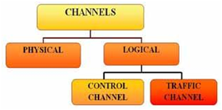
Fig 3.3: Types of Channel

Main BCCH | SCCH+CBCH | TCH | TCH | TCH | TCH | PDTCH

3.4.2. GSM Physical Channels

A single GSM RF carrier can support up to eight MS subscribers simultaneously. Each channel occupies the carrier for one eighth of the time. This is a technique called Time Division Multiple Access. Time is divided into discrete periods called “Timeslots”. The timeslots are arranged in sequence and are conventionally numbered 0 to 7]. Each repetition of this sequence is called a “TDMA frame”. Each MS telephone call occupies one timeslot (0–7) within the frame until the call is terminated, or a handover occurs. The TDMA frames are then built into further frame structures according to the type of channel. For such a system to work correctly, the timing of the transmissions to and from the mobiles is critical. The MS or Base Station must transmit the information related to one call at exactly the right moment, or the timeslot will be missed.

The information carried in one timeslot is called a “burst”. Each data burst, occupying its allocated timeslot within successive TDMA frames, provides a single GSM physical channel carrying a varying number of logical channels between the MS and BTS

3.4.3. GSM Logical Channels
GSM Logical Channels consists of two types: Control Channels and Traffic Channels. Control Channels further consists of three Groups namely
Broadcast Control Channel, Common Control Channel and Dedicated Control Channel.
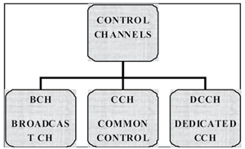
Fig 3.4: Types of Control Channels
Broadcast Control Channel (BCH)
The Broadcast Control Channels are downlink only (BSS to MS) and it carries the CGI (Cell Global Identity). It also sends control information to MS (Mobile Station). The information carried on the BCCH is monitored by the MS periodically (at least every 30 sec), when it is switched on and not in a call.

Common Control Channel
The Common Control Channel (CCCH) is responsible for transferring control information between all mobiles and the BTS.
Dedicated Control Channel
Dedicated Control Channels are both Uplink and Downlink and has further categories: SDCCH, SACCH, and FACCH.

3.4.3. Traffic Channels
The traffic channel carries speech or data information. It is further of two types: Full Rate and Half Rate which are of again of two types namely Net Rate and Gross Rate.
Full Rate/ Half Rate
In Full Rate, 1 Subscriber uses 1 Time Slot which means in TDMA Frame there are total 8 Subscribers while case of Half Rate, 1 Time Slot is used by 2 Subscribers on sharing bases that means 16 Subscribers in 1 TDMA Frame.
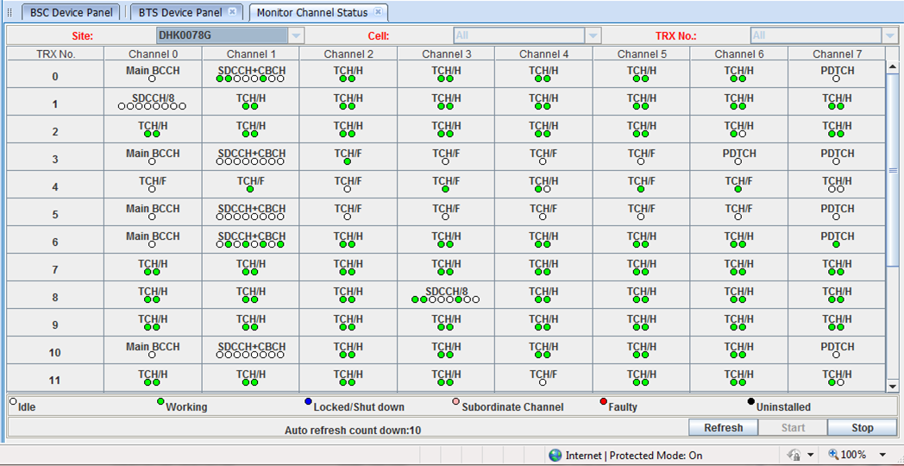
Fig 3.5: Channel Status of BTS in M2000 (Description of M2000 is given in Chapter 5)
In the screenshot of M2000 [Fig 3.5], we can see that there is a live monitor channel status of a BTS (DHK0078G). There are 12 TRX in 5 cells.
From TRX 0, I’d like to show –
- Main BCCH 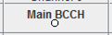
- SDCH + CBCH 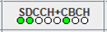
- TCH (Half) 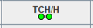
- PDTCH 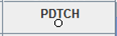

As there is no TCH full rate in TRX 0, From TRX 3 (Channel 2) –
- TCH (Full) 