|  |
| --- |
| Chapter 2: 3G |

Third Generation (3G) telecommunication networks support services that provide an information transfer rate of at least 200Kbps. However, many services advertised as 3G provide higher speed than the minimum technical requirements for a 3G service. Recent 3G releases often denoted 3.5G and 3.75G also provide mobile broadband access of several Mbps to smart phones and mobile modems in laptop computers.

3G finds application in wireless voice telephony, mobile internet access, fixed wireless Internet access, video calls and mobile TV.

* 1. **Introduction to 3G**

The next generation of wireless network technology is 3G that provides high speed bandwidth (high data transfer rates) to handheld devices. The high data transfer rates will allow 3G networks to offer multimedia services combining voice and data.

Specifically, 3G wireless networks support the following maximum data transfer rates:

* 2.05 Mbits/second to stationary devices.
* 384 Kbits/second for slowly moving devices, such as a handset carried by a walking user.
* 128 Kbits/second for fast moving devices, such as handsets in moving vehicles.

These data rates are the absolute maximum numbers. For example, in the stationary case, the 2.05 Mb/second rate is for one user hogging the entire capacity of the base station. This data rate will be far lower if there is voice traffic (the actual data rate would depend upon the number of calls in progress).

The maximum data rate of 128Kbits/second for moving devices is about ten times faster than that available with the current 2G wireless networks. Unlike 3G networks, 2G networks were designed to carry voice but not data.

3G wireless networks have the bandwidth to provide converged voice and data services. 3G services will seamlessly combine superior voice quality telephony, high speed mobile IP services, information technology, rich media, and offer diverse content.

Some characteristics of 3G services that have been proposed are:

* Always-on connectivity. 3G networks use IP connectivity, which is packet based.
* Multi-media services with streaming audio and video.
* Email with full-fledged attachments such as PowerPoint files.
* Instant messaging with video/audio clips.
* Fast downloads of large files such as faxes and PowerPoint files.
* Access to corporate applications.

**3G Technology Summary**

* Technology Convergence on Wideband-CDMA
* CDMA 2000
  + Successor to CDMA IS-95, 4 core standards – 1xRTT, 1x EV-DO, 1x EV-DV, 3xRTT
  + 1xRTT provides 2x voice capacity increase over IS-95 and a peak data rate of 144kbps
  + EV-DO Rev A provide peak data rates of 3.1 downlink / 1.8 uplink (800kbps typical)
* UMTS
  + Successor to GSM, based on W-CDMA
  + Peak data rates of up to 1920kbps (384kbps typical)
  + HSDPA peak data rate of up to 14.4Mbps
  1. **WCDMA a development from GSM and CDMA**

Naturally there are a lot of differences between WCDMA and GSM systems, but there are many similarities as well.

The GSM Base Station Subsystem (BSS) and the WCDMA Radio Access Network (RAN) are both connected to the GSM core network for providing a radio connection to the handset. Hence, the technologies can share the same core network.

Furthermore, both GSM BSS and WCDMA RAN systems are based on the principles of a cellular radio system. The GSM Base Station Controller (BSC) corresponds to the WCDMA Radio Network Controller (RNC). The GSM Radio Base Station (RBS) corresponds to the WCDMA RBS, and the A-interface of GSM was the basis of the development of the Iu-interface of WCDMA, which mainly differs in the inclusion of the new services offered by WCDMA.

The significant differences, apart from the lack of interface between the GSM BSCs and an insufficiently specified GSM Abis-interface to provide multi-vendor operability, are more of a systemic matter. The GSM system uses TDMA (Time Division Multiple Access) technology with a lot of radio functionality based on managing the timeslots. The WCDMA system on the other hand uses CDMA, as described below, which means that both the hardware and the control functions are different. Examples of WCDMA-specific functions are fast power control and soft handover.

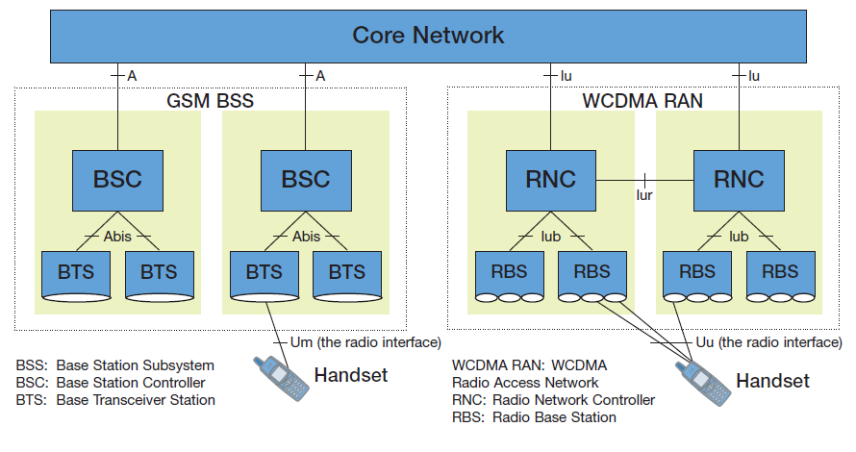

*Fig 2.1: GSM/WCDMA Architecture.*

* 1. **Advantages and Disadvantages of 3G**

**Advantages of 3G**

3G networks offer users advantages such as:

* New radio spectrum to relieve overcrowding in existing systems.
* More bandwidth, security, and reliability.
* Interoperability between service providers.
* Fixed and variable data rates.
* Asymmetric data rates.
* Backward compatibility of devices with existing networks.
* Always-online devices. 3G will use IP connectivity, IP is packet based (not circuit based).
* Rich multimedia services.

**Some Disadvantages of 3G**

There are some issues in deploying 3G:

* The cost of upgrading base stations and cellular infrastructure to 3G is very high.
* Requires different handsets and there is the issue of handset availability. 3G handsets will be a complex product. Roaming and making both data/voice work has not yet been demonstrated. Also the higher power requirements (more bits with the same energy/bit) demand a larger handset, shorter talk time, and larger batteries)
* Base stations need to be closer to each other (more cost).
* Tremendous spectrum-license costs, network deployment costs, handset subsidies to subscribers, etc.
* Wireless service providers in Germany and Britain who won spectrum licenses in auctions, paid astronomical prices for them. As a result, they have little money left for building the infrastructure. Consequently, deployment of 3G in Germany and Britain will be delayed.
  1. **Access Technology**

W-CDMA stands for Wideband Code Division Multiple Access is a third generation’s important feature based on radio transmission system. It is designed by ETSI Alpha organization. It is quite challenging to apply it because of its complex features and versatile properties.

**Properties:** Make hybrid with IS-95 (digital cellular standard) component of 2G technology responsible for the high frequency (TX: 1920-1980 MHz and RX: 2110 - 2170 MHz). It is able to download 14.7 Mbps, provide wideband known as Spread Spectrum in addition to code division multiple accesses, improved audio-visual effects.

**Access Mode:** W-CDMA stands for Wideband Code Division Multiple Access is a third generation’s important feature based on radio transmission system. It is designed by ETSI Alpha organization. It is quite challenging to apply it because of its complex features and versatile properties.

**Data Transfer Rate:** Also in the recent years, 3G networks are able to achieve speeds of more than 384 kbps which allows full mobility to 3G phone users traveling at a speed of 120 km/hour in outdoor settings. 3G systems are also able to achieve a maximum speed of 2 Mbps which allows 3G users with limited mobility walking less than 10 miles per hour in short-range indoors or stationary environments.

Another advantage of 3G is that it is capable of HSPA data transmission through which it is able to deliver speeds up to 5.8 Mbps on uplink and 14.4 Mbps on downlink so what are you waiting for, go ahead and buy your 3G phone.

* 1. **WCDMA Key Benefits:**
* Soft Handover: Call is connected before handover is completed, reducing the probability of a dropped call.
* Processing Gain: Basic CDMA benefit => the wider the transmitted bandwidth compared to the user data rate the less power is needed for the transmission.
* Advanced Radio Resource Management (RRM): RRM will control call admission and packet scheduling and all RRM building blocks are closely related to each other.
* Multipath Signal Processing: Combines power for increased signal integrity => RAKE receiver.
  1. **Cell breathing:**
* Considering the limitation of maximal transmit power, the increase of required received power due to high traffic that will lead.
* The cell coverage decreases when the traffic increases : so-called “cell breathing” phenomenon
* Coverage and capacity are linked in CDMA systems

*Fig 2.2: Call Breathing.*

* 1. **Mostly Used Features of 3G Technology:**

Previously mobile phones were using GPRS (32 - 48 Kbps) or EDGE (384 Kbps) technology for data transfers. The rate of transfer was so slow that it indeed tested the user's patience. The chief advantage of 3G is that all data transfer over the phone can now take place at a much faster speed. The main advantage of 3G technology is high speed data transfer rate which allows mobile phone subscribers freedom to have few basic advantages:

1. **Video Conference:** You can conduct video-conferencing, and also you can see the person to whom you are talking when you make calls, provided the other person also is using a 3G enabled device. This is in contrast to conventional voice calls where you are restricted to hearing only the voice of the person at the other end.
2. **Lightening Fast Internet Service:** 3G internet has not only made your mobile handset better equipped but your PC or laptop also. 3G Data Cards or 3G USB Modems have been launched by most of the leading Internet Service Providers. You just need to plug in your 3G modem into the USB slot, and access internet on your computer at lightning speed.
3. **High Download Speed:** 3G technology is basically all about speed and high data transfer rate. All the things that you could earlier do on your internet enabled phone, you can do all those now at a faster speed. For instance, you can download songs, movie trailers, sound clips and even complete movies into your phone. What took 2 hrs earlier, the same will now execute in a matter of a few minutes.
4. **Map & Positioning Services:** You can use map and positioning services. The 3G enabled handset can determine its current location on the inbuilt map, and can give you directions to go to a certain place from its present location. It can even give you driving directions.
5. **Online Multiplayer Gaming:** If you are a fan of computer games then 3G is the perfect solution for you. By virtue of the 3G internet technology you can play multiplayer games with co-players across the globe, right on your cell phone or on your PC.
6. **Watch Your TV or Video:** By virtue of 3G Internet, you no longer need to wait to go to the cinema or even get into your drawing room to watch on the television the latest movie released. You can watch it right in your phone while sitting in your car or during break-time at office. Also, you can very comfortably catch up with your favorite TV shows no matter day or afternoon.

3G services will enable video broadcast and data-intensive services such as stock transactions, e-learning and telemedicine through wireless communications. 3G is stimulant that makes you frenzy with whole world of internet and other services experience. Be it Live Matches, News, Live Streaming of video/music or online gaming. 3G give you instigative speed and encouragement to explore more. Technically, 3G in Mobile communication refers to 3rd generation mobile telephony which supports video calls, high speed internet, live streaming like facilities.

* 1. **Other W-CDMA particularities:**
* No frequency reuse pattern
* Scrambling code planning required
  + 512 scrambling codes in W-CDMA
* Soft-handover capability
* RAKE receiver

**Other Topics:**

* User Equipment configuration & supported OS
* Data over use due to unknown auto updates of various software and tools.
* Power economy of the set.
* Call drop issues
  + Cable, connector, antenna faulty.
  + Inefficient earthling system for feedback relay.